**MongoDB Assignment 1**

**Query Insert documents:**

**Query / Find documents**

Query the movies collection to

1: Get all documents

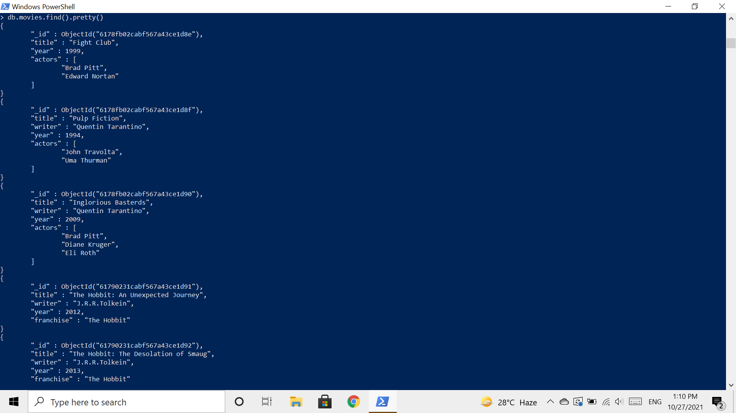

2: get all documents with writer set to “Quentin Tarantino

3: get all documents where actors include “Brad Pitt”.

4: get all documents with franchise set to “The Hobbit”.

5: get all movies released in the 90s.

6:get all movies released before the year 2000 or after 2010

**Update Documents**

**1.add a synopsis to "The Hobbit: An Unexpected Journey": "A reluctant hobbit, Bilbo Baggins, sets out to the Lonely Mountain with a spirited group of dwarves to reclaim their mountain home - and the gold within it - from the dragon Smaug."**

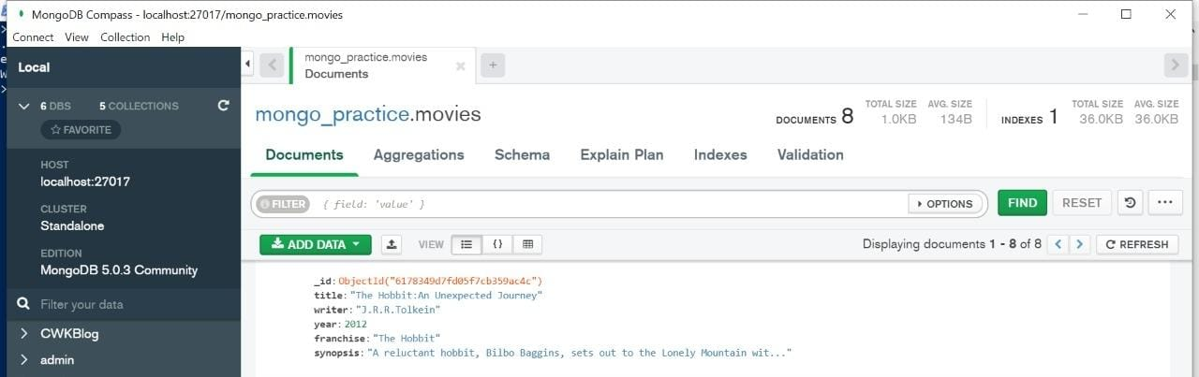



**2. add a synopsis to "The Hobbit: The Desolation of Smaug" : "The dwarves, along with Bilbo Baggins and Gandalf the Grey, continue their quest to reclaim Erebor, their homeland, from Smaug. Bilbo Baggins is in possession of a mysterious and magical ring."**

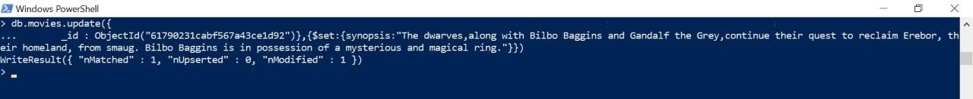

**3.add an actor named "Samuel L. Jackson" to the movie "Pulp Fiction".**



**TEXT Search**

**1.find all movies that have a synopsis that contains the word “Bilbo”.**

**2. find all movies that have a synopsis that contains the word “Gandalf”.**

**3.find all movies that have a synopsis that contains the word “Bilbo” and not the word “Gandalf”.**

**4. find all movies that have a synopsis that contains the word “dwarves” or “hobbit”.**

**5. find all movies that have a synopsis that contains the word “gold” and “dragon”.**

**DELETE Documents**

**1.delete the movie “Pee Wee Herman’s Big Adventure”.**

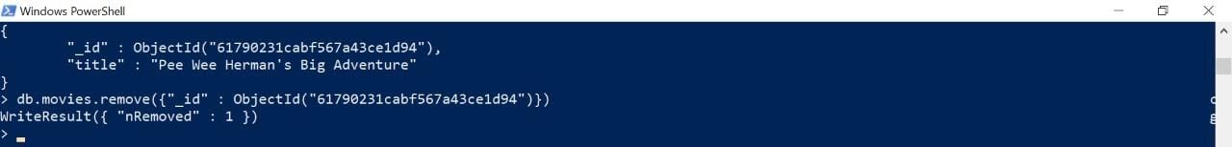

**2. delete the movie “Avatar”.**

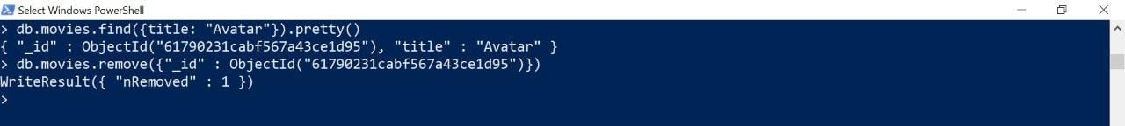

**Relationships**

**1.Insert the following documents into a users collection.**

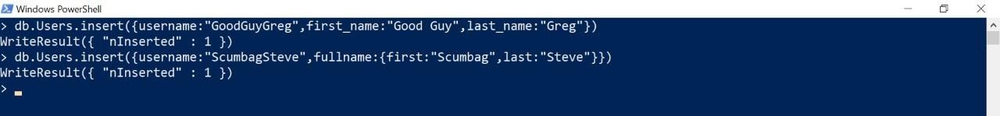

**2.Insert the following documents into a Posts collection.**

**3. Insert the following documents into a comments collection.**



**Querying related collections**

**1.find all users.**

**2.find all posts.**

**3.find all posts that was authored by “GoodGuyGreg”.**

**4.find all posts that was authored by “ScumbagSteve”.**

**5.find all comments.**

**6.find all comments that was authored by “GoodGuyGreg”.**

**7.find all comments that was authored by “ScumbagSteve”.**

